PHSA
undergrad

Additional links
Community Outreach Opportunities

Issue IV | Vol. I | Monthly Periodical | October 30, 2018

WE ARE 11 WEEKS INTO THE SEMESTER…

The end of the semester is approaching now faster than ever! Make these your best weeks yet & finish strong. As we maneuver through the remainder of the semester, Public Health Student Association has opportunities for involvement.

NOVEMBER NEWS
Oct. 31  PHSA Meeting 6:30pm STON 215  All Month  Prematurity Awareness Month | Nov. 10—14  APHA Annual Meeting  San Diego, CA  Additional links Community Outreach Opportunities | Nov. 28  PHSA Meeting 6:30pm STON 215  Spring 2019 meeting dates  HK Research Assistant Spring 2019 opening
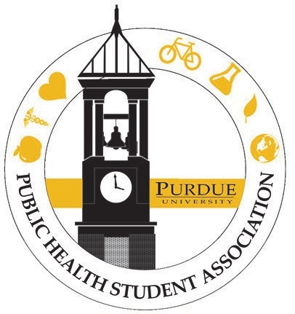
First, we invite you to contribute an idea and post for our online blog and student spotlight. Many people visit our site daily and this offers a space for showcasing your critical thinking and analytical skills on a public platform.

Second, PHSA’s first book club meeting is Friday, November 16, 2018 9:00am-10:00am-- location TBD. Please RSVP. The book of discussion is When Germs Travel Six Major Epidemics That Have Invaded America and the Fears They Have Unleashed. This is one of many ways to intermingle with Public Health graduate students. The connections you build now last a lifetime! If you’d like to also opt into the graduate student email list, please do so here.

Lastly, please attend the undergrad monthly meetings on Wednesday, October 31, 2018 and Wednesday, November 28, 2018 in Stone Hall— Rm. 215. During this time, we will strategize ways to further engage with our campus community and beyond. We will also discuss the formation of committees for Spring semester events.

Let’s also give a special shout out to
our University for turning 150 years
old this year! Boiler up!

